# Version 3

So, there is a new version for this website, and it’s new because we are going to change several things:

1.- the color schema, the girls did not like the first picked out colors, so we are going to change it up a bit. We are now going to use this pallet:

And of course, the new logo.

## To-do tasks, front end:

### 1.-Navbar and Footer

**Change color schema:** on navbar and footer

Add the new logo

### 2.- New looks on the webpage

Make it so that we could import the nav and footer

Gap the sides of the page so it could look clean.

Edit out the breadcrumbs or change the color, use proper judgement to remove or keep.

Colors from the new palette, the order is from the highest to lowest color.

#03204C

#04396B

#025B95

#6497B2

#B2CDE0

## To-do tasks for the pdf upload page:

### 1.- new pdf algorithm

Moving from BLOB to root folder

### 2.-Discussion and investigation

Discussion and investigation to find a search method having the pdfs saved in the root folder.

De aquí para abajo ya seria después de completar los 2 anteriores, ya que depende de los cambios generados en los pasos anteriores.

# To-Do tasks for the page in the website, sign in

### 1.- Add the nav, footer and breadcrumbs

Since it’s a new page, just copy and paste the current nav, footer and breadcrumbs.

PS: I might have the first tasks done which is to invoke the nav and footer instead of copy and paste.

### 2.- Develop the form for sign in

Develop this front-end work with bootstrap

### 3.-Make the Database registry with MySQL

This is just the admin username and password saved in a table of the project.

# New ideas

Change the NavBar

So when these girls have all of the 700 something files that they need to be in the webpage, it is going to be a lot of clicking. Find a better way to upload these files.

What was done today 2/3/2020

There was a couple of changes made in the page, that I will continue some other time, tomorrow probably

This is the github repository

https://github.com/pknowledge/userlogin/blob/master/login.php

So I left off in this tutorial <https://www.youtube.com/watch?v=wdE5K-DvoZE>, making the login from the database thru ajax and php.

Tasks that were not completed were:

Making the new page which is the admins main page

How to disable a button on javascript

<https://www.youtube.com/watch?v=vU2akkcSV-g>

So im making the addpdf.php or edting it, and I left of doing this gist snippet: <https://gist.github.com/psgareja/7cf1fe368cea94405700fca976be54d7>

And this stackoverflow page: <https://stackoverflow.com/questions/833012/how-to-validate-a-file-upload-field-using-javascript-jquery>

At this point in the webpage we are doing more estitic changes on the webpage, I have updated now the addpdf.php file and now it looks like this:

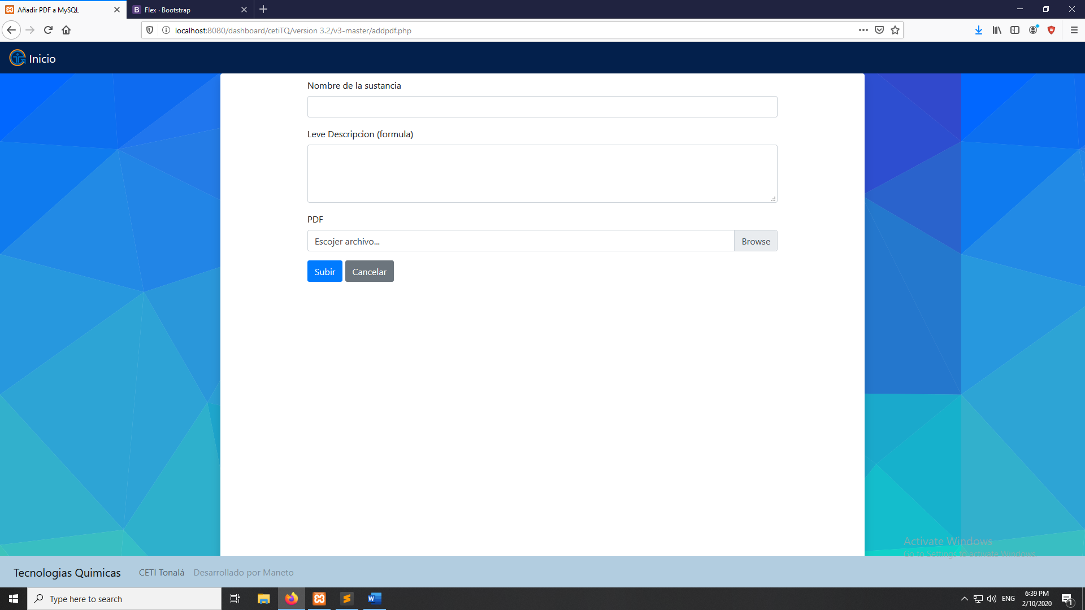

Also we put in the newer logo

Here is some new task for the next day of coding this webpage:

The browse tab for choosing a file does not update to the name of the file that you want to upload.

The JavaScript does not show the alert yet on the click of the button.

## Editado de la página admin.php

Eliminado los containers

Queda solo 1 container ahora

Ajustes al container

## adminNavbar

Nuevo toggler

Los botones ahora te llevan a paginas

## Jslogin

Ahora al iniciar sesión te manda a la página de admin.php

Como usar Query **LIKE** en MySQL para consultas

<https://www.mysqltutorial.org/tryit/query/mysql-like/#3>